**DOCUMENTATION OF DATA**

**ANAYLIS...**

Subscribers Galore : Exploring World’s Top

YouTube Channels

COMPLETED BY:

M. PRIYA

R.PRIYADHARSHINI

D.NITHYA

R. PANDIRAJA

**PROJECT FLOW**

1.Documentation

2.Introduction

* Overview

3.Problem definition

EMPATHY MAP

IDEATION & BRAINSTROMING MAP

4.Datasheet collection

5.Data preparation

6.Dashboard

7.Story

8.Publishing

9.Project Demonstration/ Documentation

**OVERVIEW**

**INTRODUCTION:**

A subscriber to a channel on the video-sharing YouTube is a user who has chosen to receive the channel's content by clicking on that channel's "Subscribe" button, and each user's subscription feed consists of videos published by channels to which the user is subscribed.

**PROBLEM DEFINITION:**

IT DEFINES THE USER FEELS ,THINK,SAYS, DOES.

**Empathy map**

**IDEATION AND BRAINSTORMING MAP**

**EMPATHY MAP :**

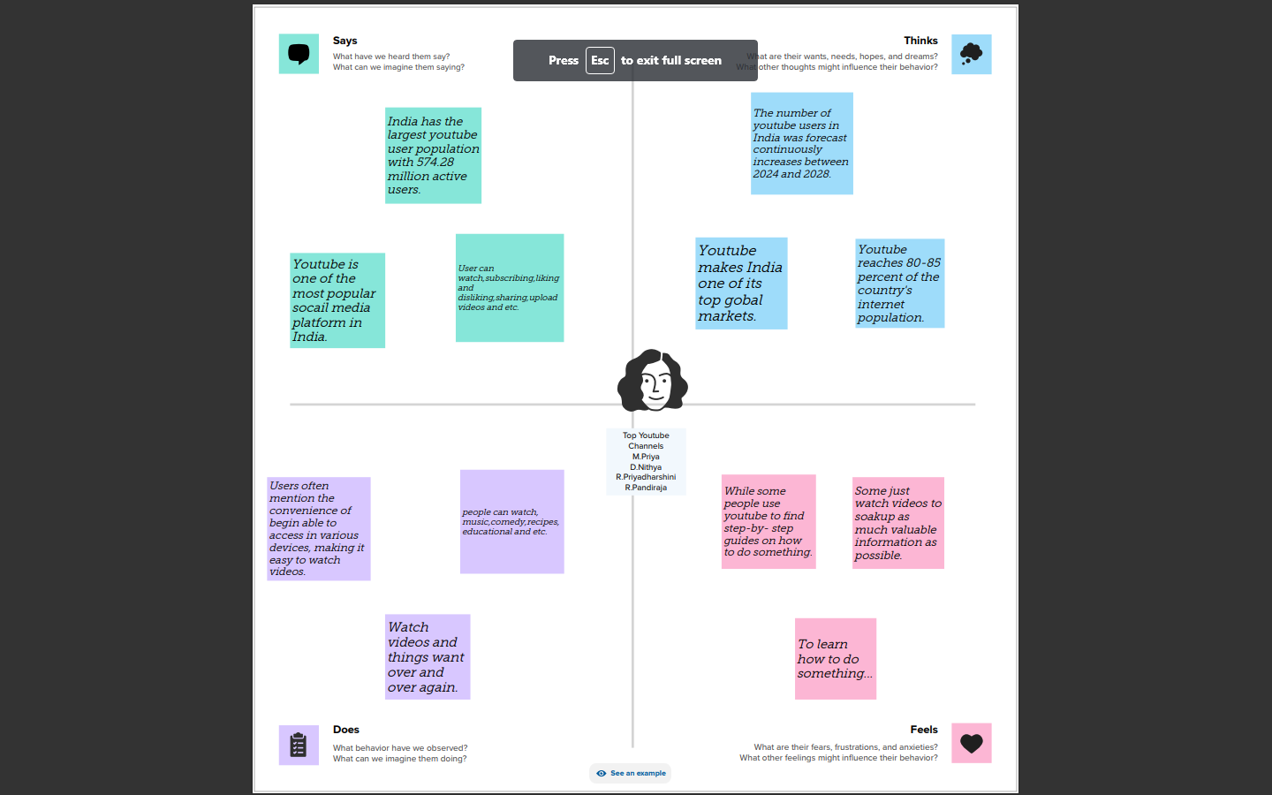

**Ideation & brain storming map :**

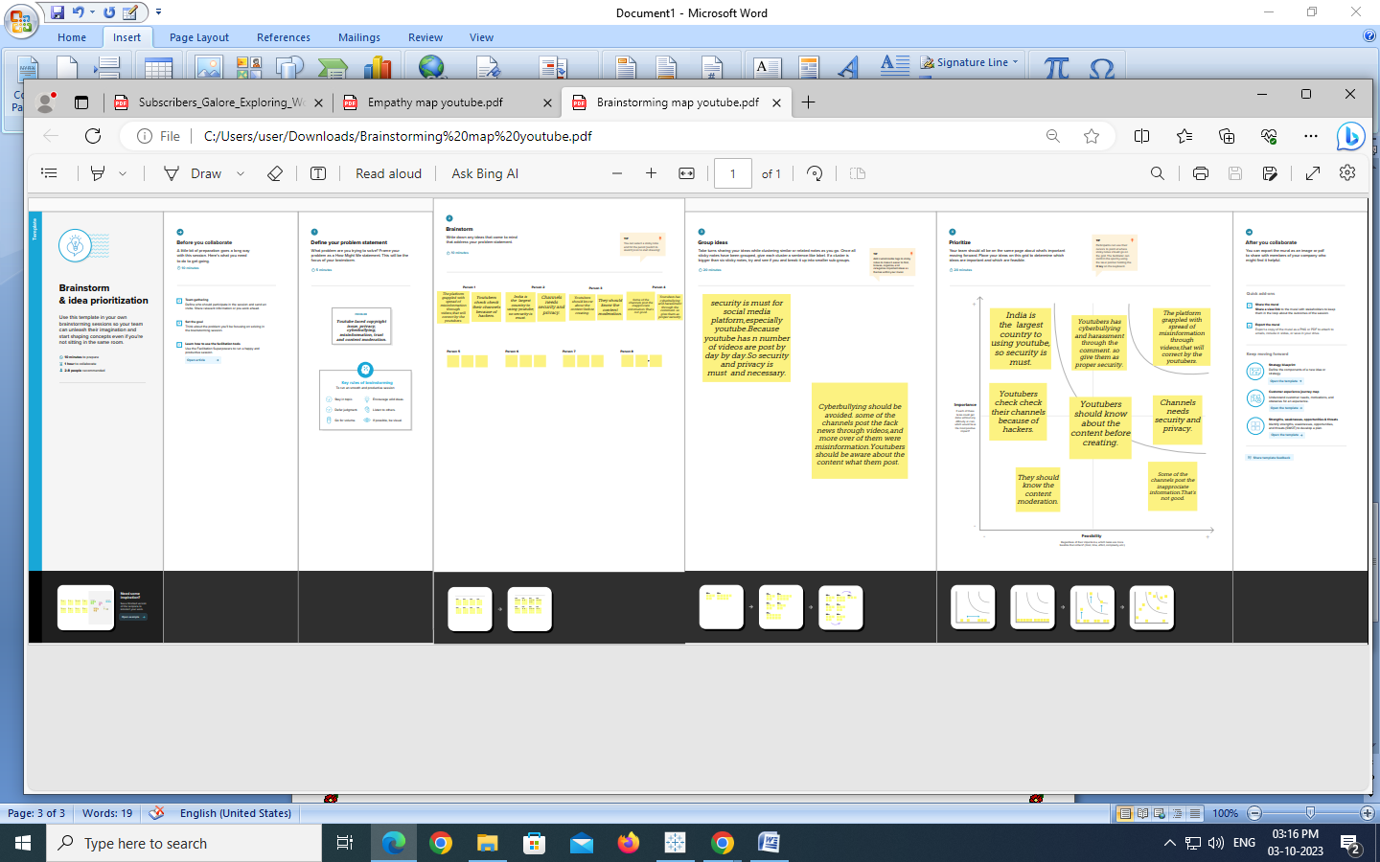

**DATA COLLECTION :**

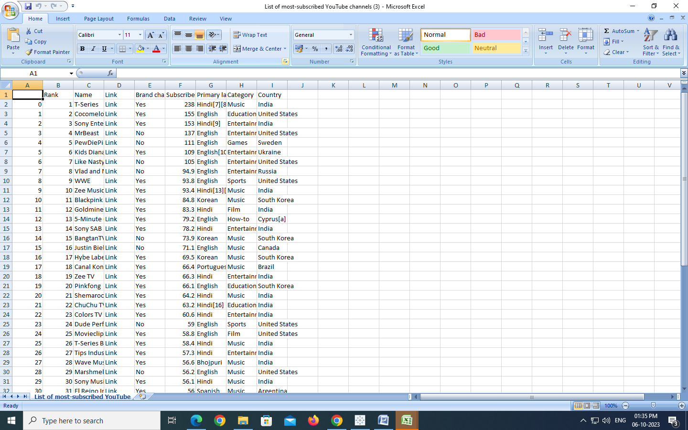

**DATA SHEET PREPARATION**

**MILESTONE 1 :**

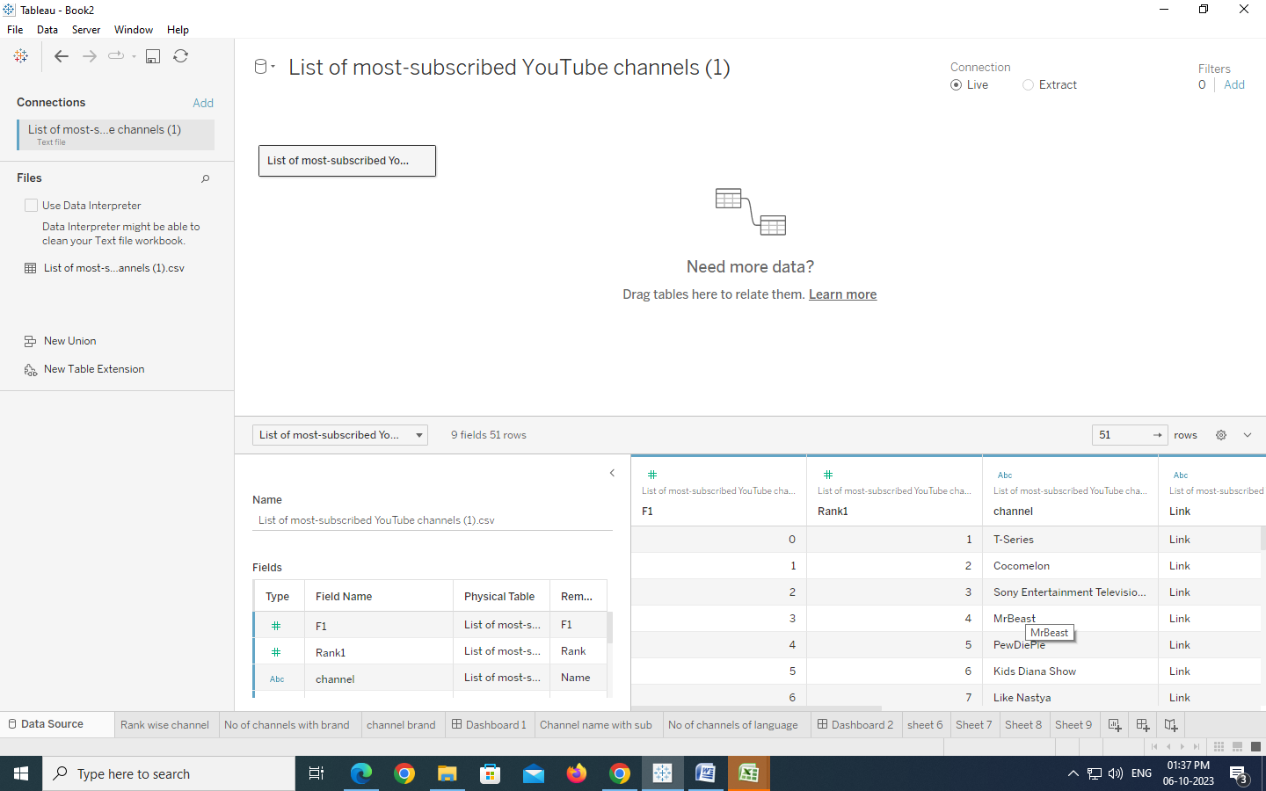

**Activity 1: No of Unique Visualizations**

**Rank wish Channel, No of Channels with Brand And Channel Brand Explanation video link:**

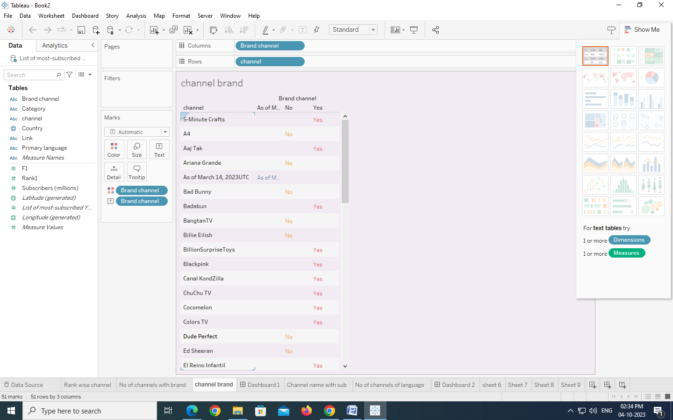

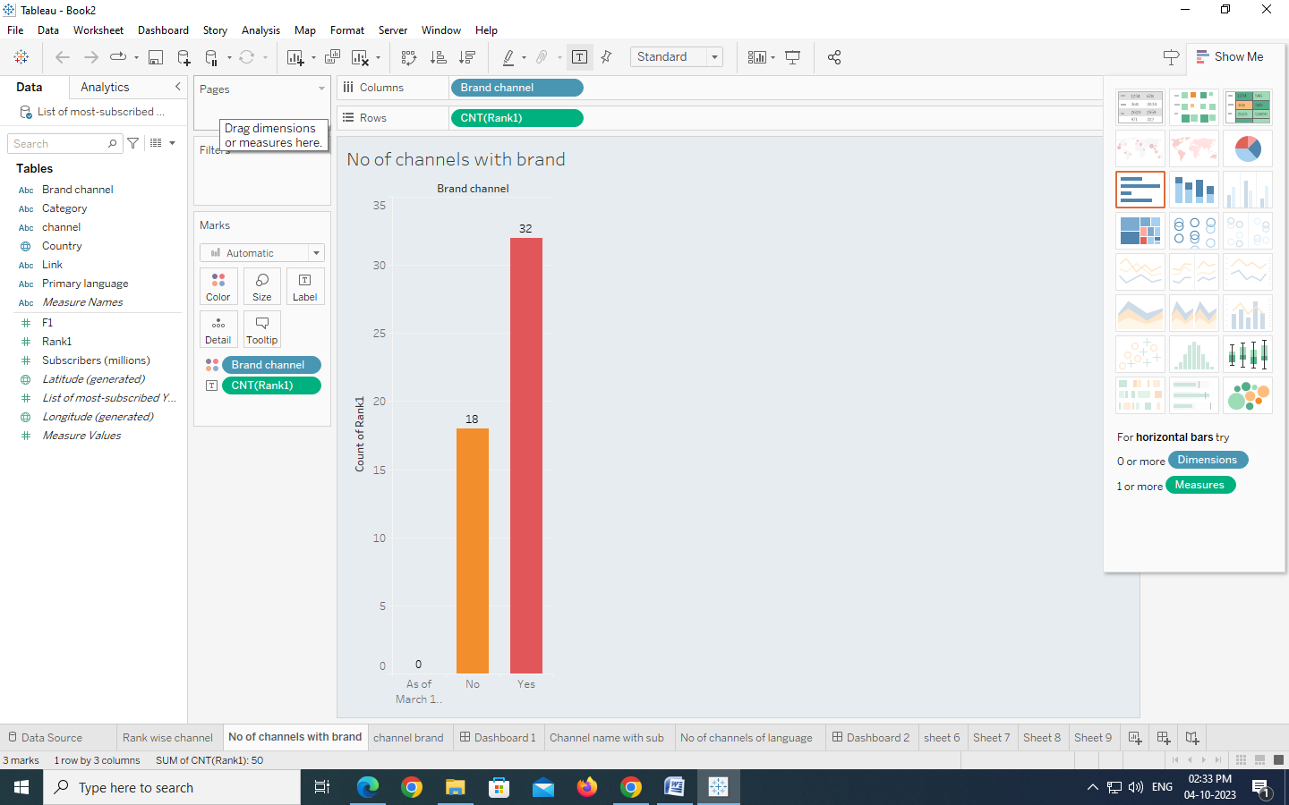

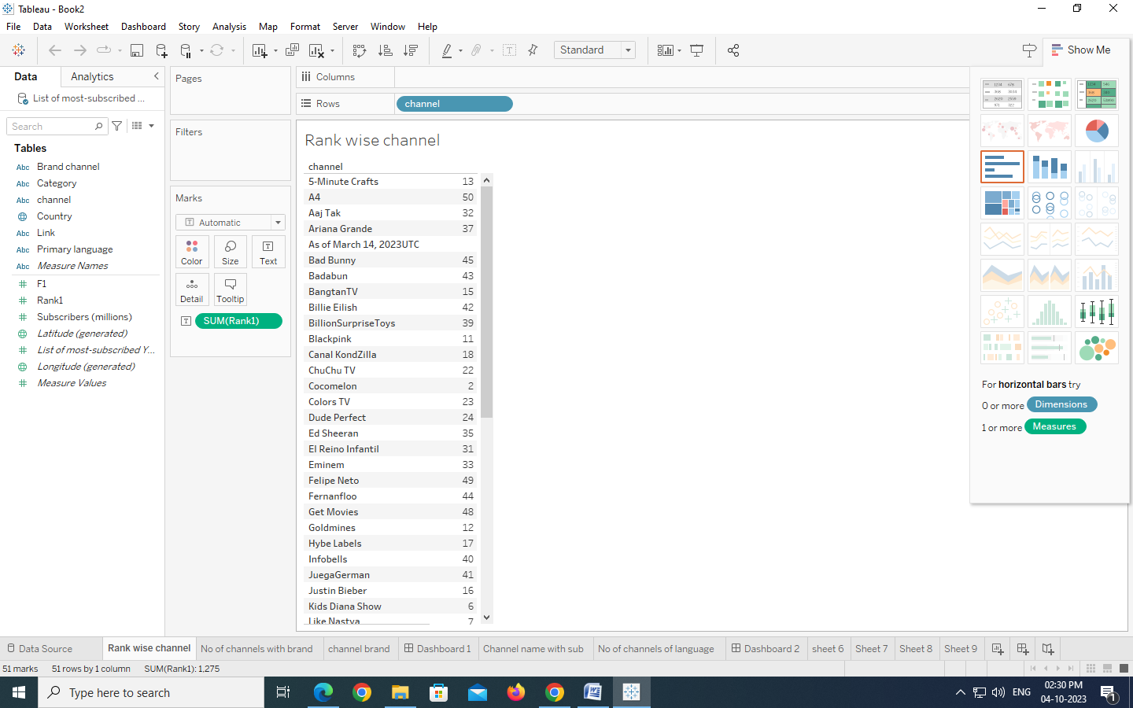

**drive_link Activity 1.2: Channel name with subscribers and No of channels for particular language**

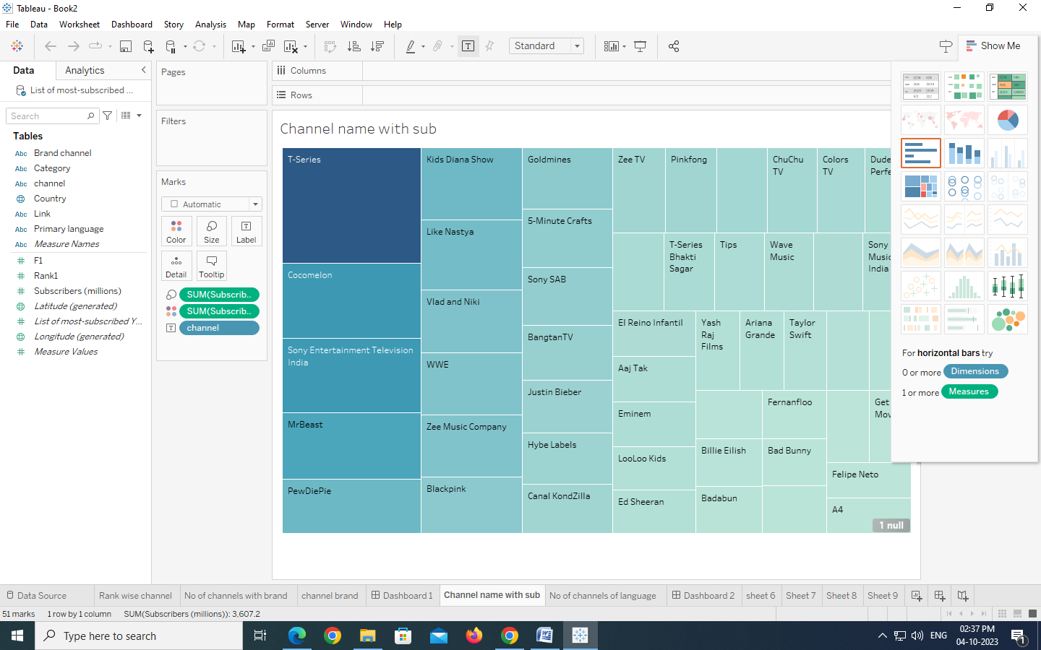

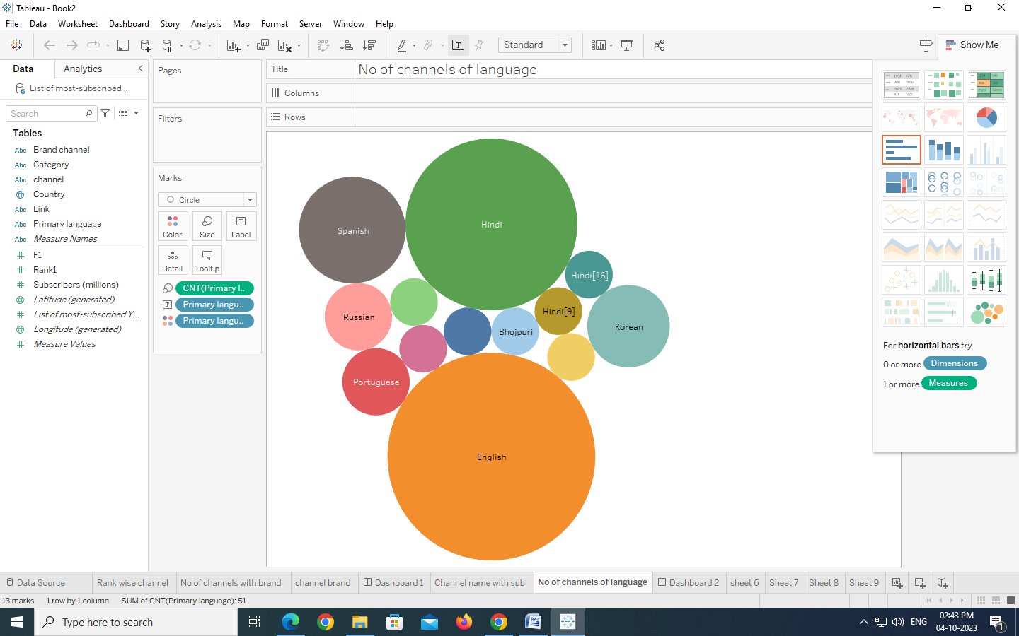

**Activity 1.3: Country and Language wise subscribers**

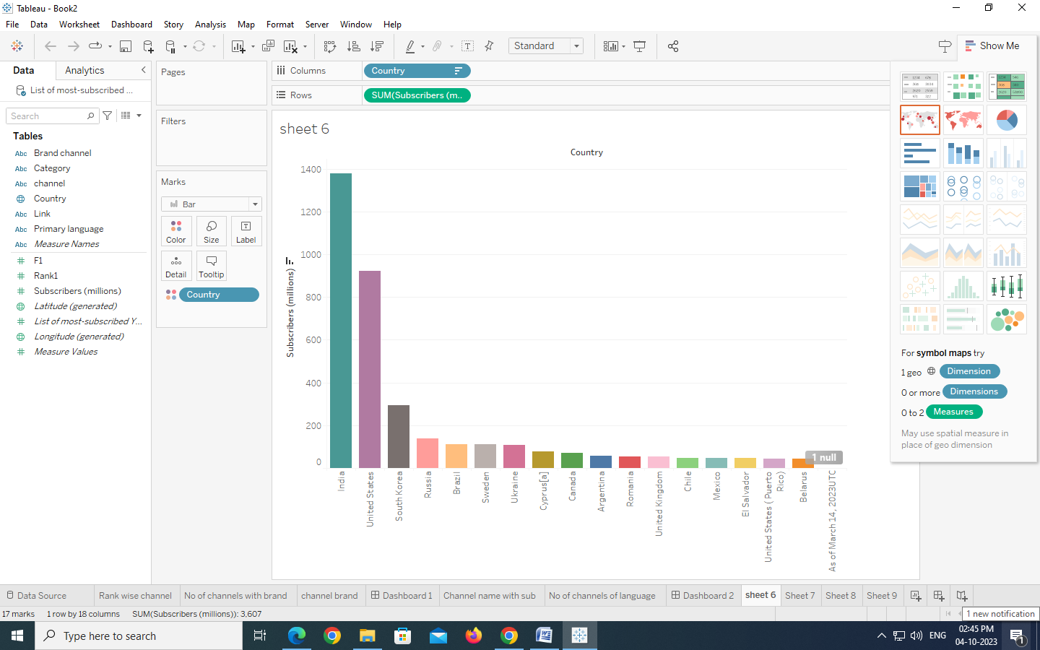

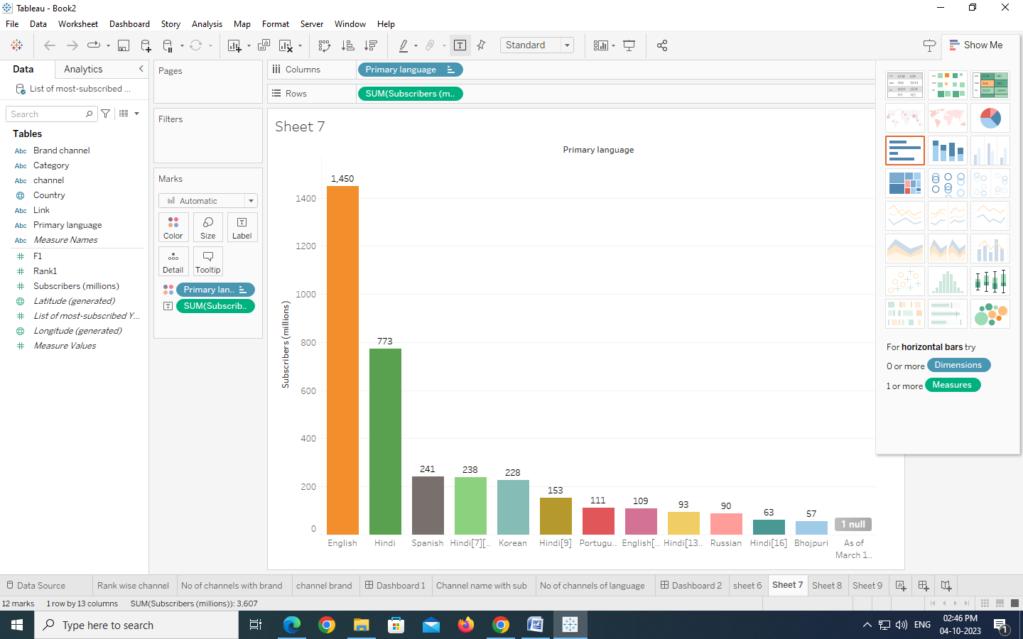

**Activity 1.4: Country wish Channel**

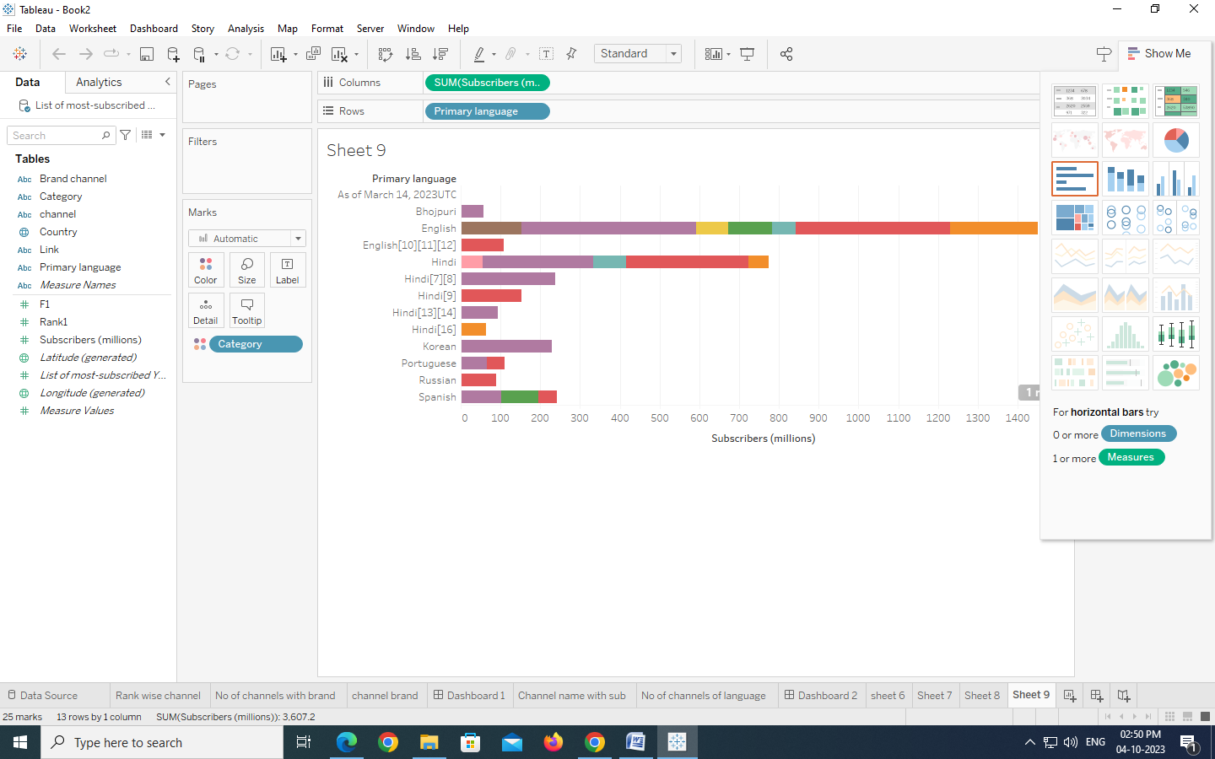**DASHBOARD**

**MILESTONE 2 :**

**Activity :1- Responsive and Design of Dashboard**

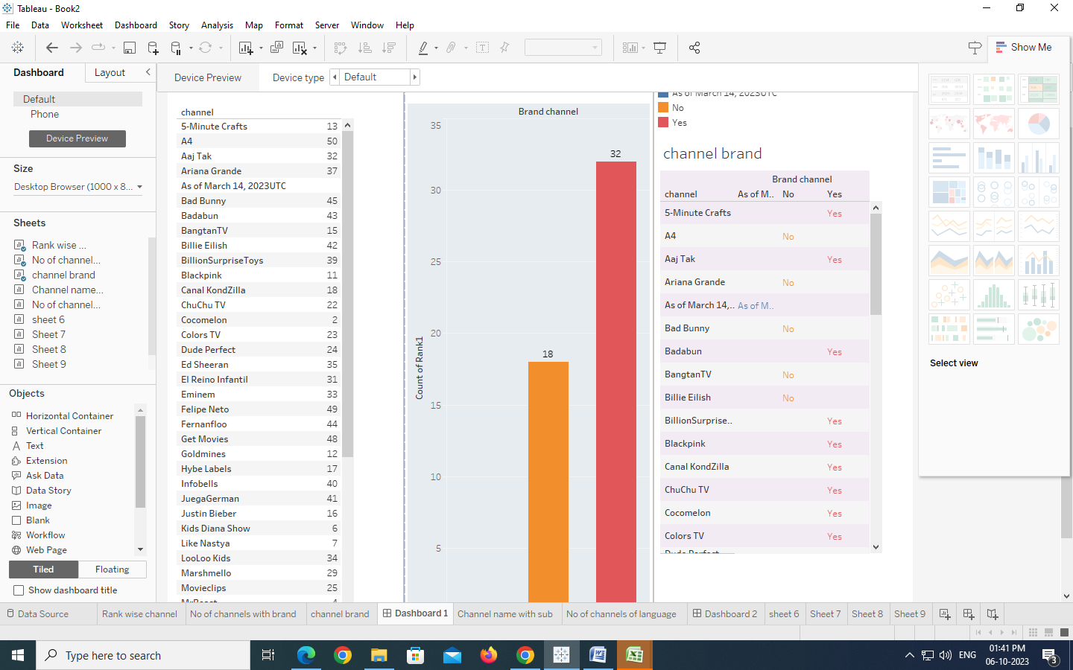

**DASHBOARD 2 :**

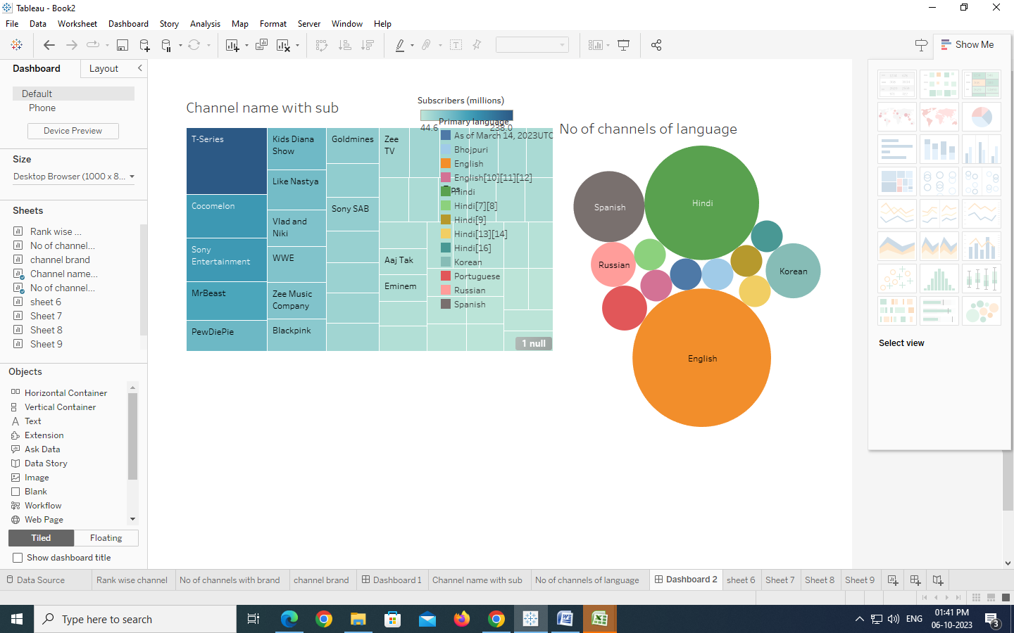

**DASHBOARD 3 :**

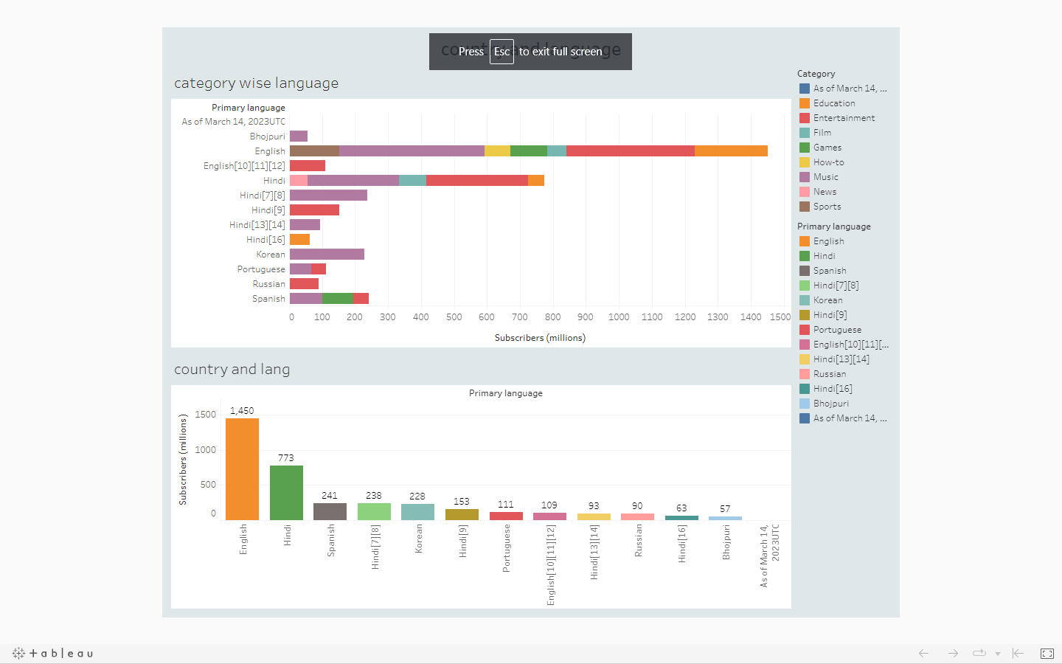

**DASHBOARD 4 :**

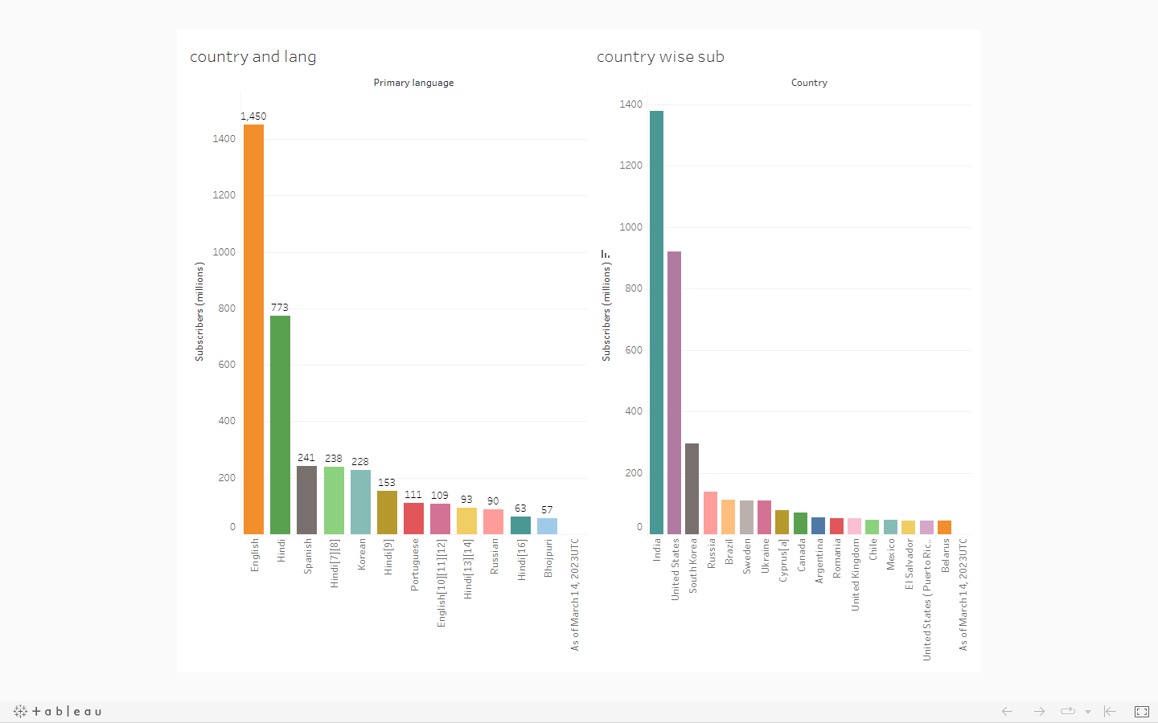

**STORY :**

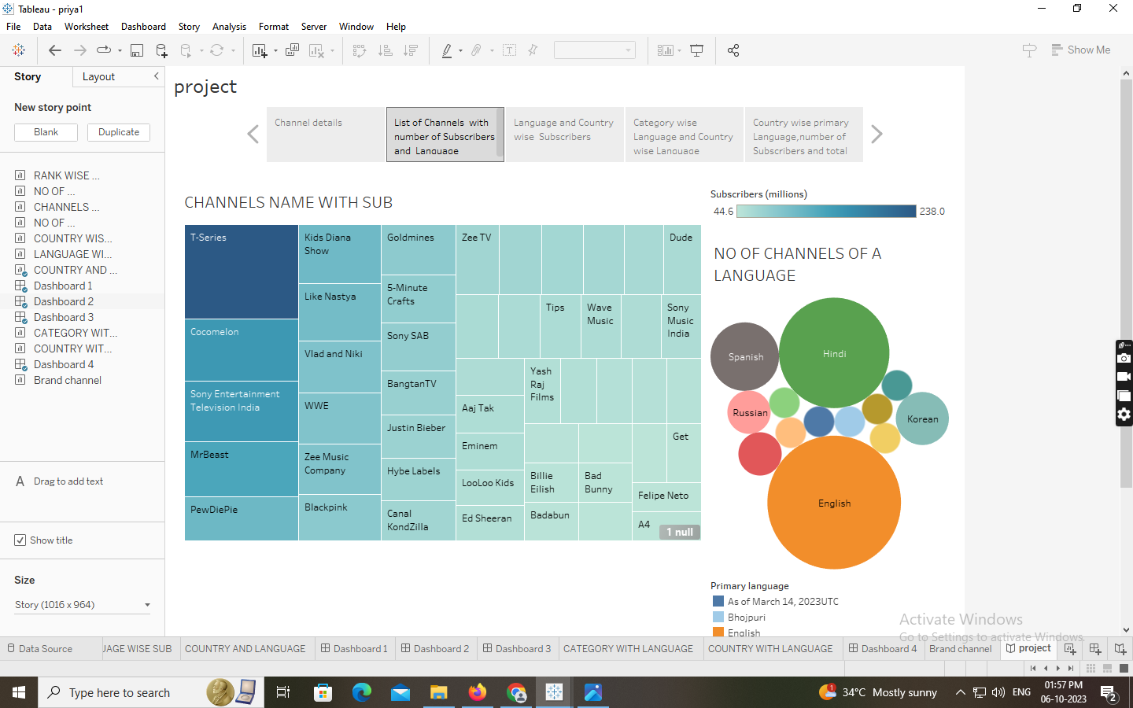



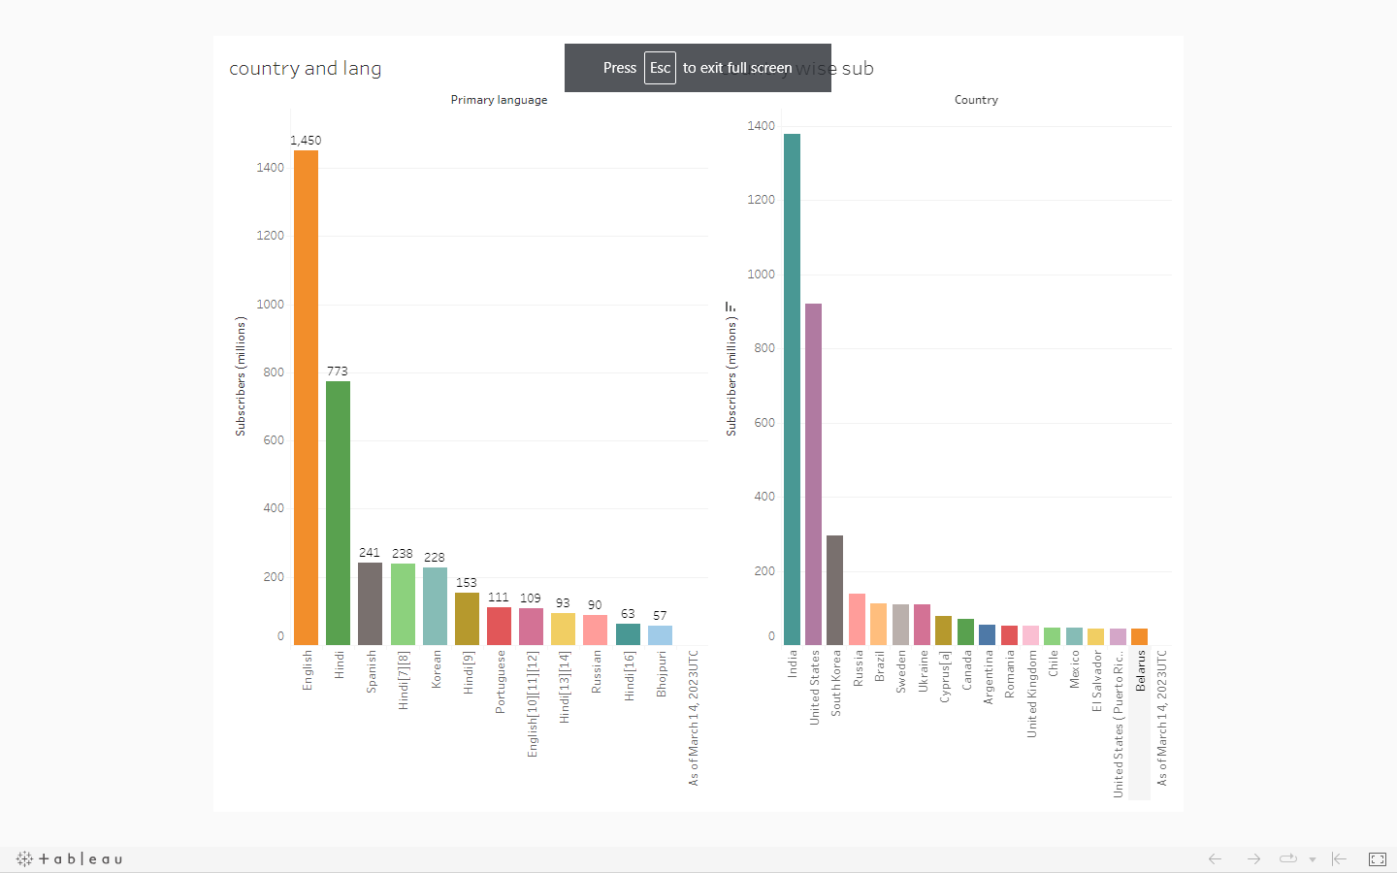



**PUBLISHING :**

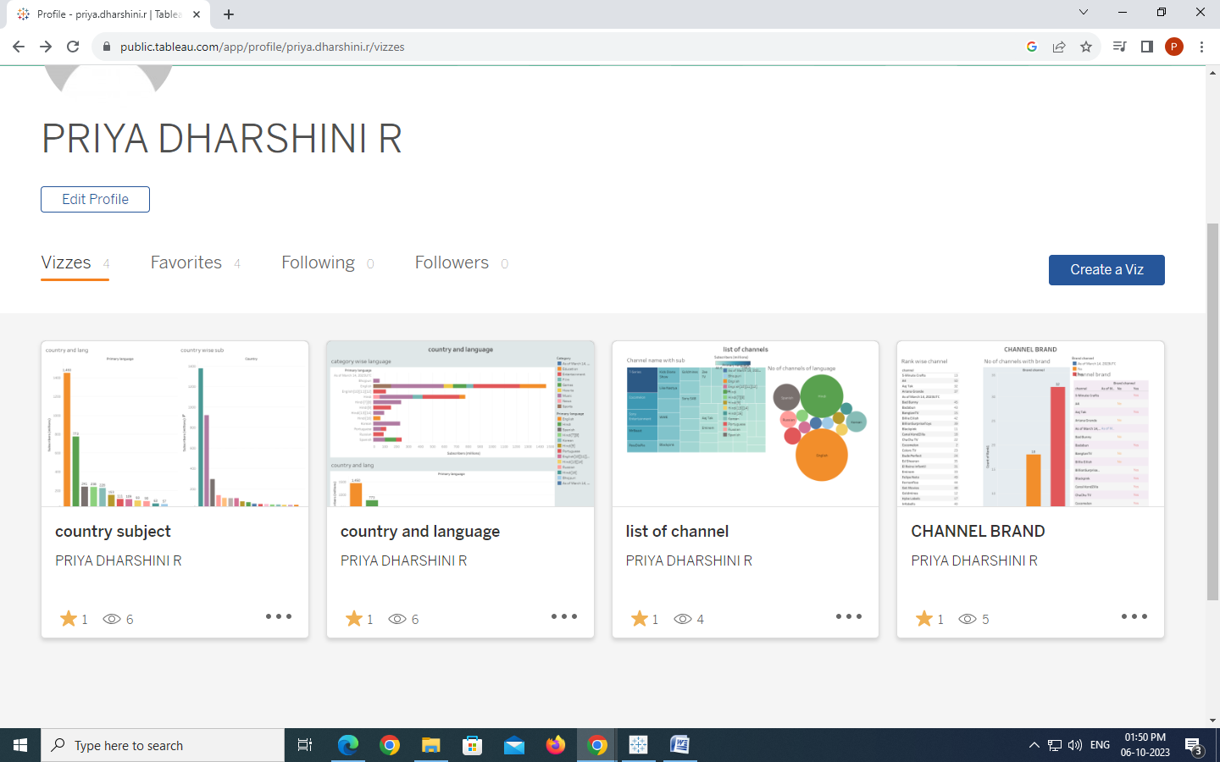

**Advantages and disadvantages:**

Advantages :

* **Exposure to a Worldwide Audience**
* **Marketing on YouTube Will Help You Get Found on Google**
* **Gain Qualified Traffic**
* **YouTube Ads Can Help You Reach Even More People**
* **Other Ways To Repurpose Your Videos**

Disadvantages :

* **EVERYTHING IS PUBLIC**
* **MANY RULES**
* **YOUR ACCOUNT CAN BE DISABLED WITHOUT ANY REASON**
* **ANY ADVERTISER CAN PUT AN ADD ON YOUR VIDEO**

Conclusion :

Users should have the ability to subscribe to their favorite YouTube channels within the platform, allowing them to receive notifications about new uploads and updates from those channels. Analytics and Insights: The platform should provide analytics and insights to track user engagement, popular channels, and trending content. This data can be used to improve content curation, personalize recommendations, and enhance the overall user experience.

Future scope :

Yes it's a good sector for passive income and better future if some one continue with his passion where he want to contribute and make sure about the quality video to your audience whatever the topic you want to work … i have personally know some people who make $3000-$5000 per month with one or two channel in ...

COURSE IN-CHARGE HOD PRINCIPAL